# (LAB: 8) Hierarchical Clustering using Agglomerative Nesting (AGNES)

Name: Debatreya Das Roll No. 12212070 CS A4 Data Mining Lab 8

### Algorithm

1. Initialize the Proximity Matrix
2. Make each point a cluster
3. Loop
   * a. Merge the 2 closest cluster
   * b. Update the Proximity Matrix
4. Until only one cluster is left

### Types of Agglomerative Clustering

(Based on How proximity between two clusters is calculated)

1. Min (Single-Link)
2. Max (Complete Link)
3. Average
4. Ward

## CODE: Hierarchical Clustering

#### Importing Required Libraries

import matplotlib.pyplot as plt  
import pandas as pd  
%matplotlib inline  
import numpy as np

#### Loading Data

customerData = pd.read_csv('./shopping.csv')  
print("SHAPE: ", customerData.shape)  
print("HEAD: \n", customerData.head())

SHAPE: (200, 5)  
HEAD:   
 CustomerID Gender Age Annual Income (k$) Spending Score (1-100)  
0 1 Male 19 15 39  
1 2 Male 21 15 81  
2 3 Female 20 16 6  
3 4 Female 23 16 77  
4 5 Female 31 17 40

#### Selecting 2 Attributes from the data for CLustering

data = customerData.iloc[:, 3:5].values  
data

array([[ 15, 39],  
 [ 15, 81],  
 [ 16, 6],  
 [ 16, 77],  
 [ 17, 40],  
 [ 17, 76],  
 [ 18, 6],  
 [ 18, 94],  
 [ 19, 3],  
 [ 19, 72],  
 [ 19, 14],  
 [ 19, 99],  
 [ 20, 15],  
 [ 20, 77],  
 [ 20, 13],  
 [ 20, 79],  
 [ 21, 35],  
 [ 21, 66],  
 [ 23, 29],  
 [ 23, 98],  
 [ 24, 35],  
 [ 24, 73],  
 [ 25, 5],  
 [ 25, 73],  
 [ 28, 14],  
 [ 28, 82],  
 [ 28, 32],  
 [ 28, 61],  
 [ 29, 31],  
 [ 29, 87],  
 [ 30, 4],  
 [ 30, 73],  
 [ 33, 4],  
 [ 33, 92],  
 [ 33, 14],  
 [ 33, 81],  
 [ 34, 17],  
 [ 34, 73],  
 [ 37, 26],  
 [ 37, 75],  
 [ 38, 35],  
 [ 38, 92],  
 [ 39, 36],  
 [ 39, 61],  
 [ 39, 28],  
 [ 39, 65],  
 [ 40, 55],  
 [ 40, 47],  
 [ 40, 42],  
 [ 40, 42],  
 [ 42, 52],  
 [ 42, 60],  
 [ 43, 54],  
 [ 43, 60],  
 [ 43, 45],  
 [ 43, 41],  
 [ 44, 50],  
 [ 44, 46],  
 [ 46, 51],  
 [ 46, 46],  
 [ 46, 56],  
 [ 46, 55],  
 [ 47, 52],  
 [ 47, 59],  
 [ 48, 51],  
 [ 48, 59],  
 [ 48, 50],  
 [ 48, 48],  
 [ 48, 59],  
 [ 48, 47],  
 [ 49, 55],  
 [ 49, 42],  
 [ 50, 49],  
 [ 50, 56],  
 [ 54, 47],  
 [ 54, 54],  
 [ 54, 53],  
 [ 54, 48],  
 [ 54, 52],  
 [ 54, 42],  
 [ 54, 51],  
 [ 54, 55],  
 [ 54, 41],  
 [ 54, 44],  
 [ 54, 57],  
 [ 54, 46],  
 [ 57, 58],  
 [ 57, 55],  
 [ 58, 60],  
 [ 58, 46],  
 [ 59, 55],  
 [ 59, 41],  
 [ 60, 49],  
 [ 60, 40],  
 [ 60, 42],  
 [ 60, 52],  
 [ 60, 47],  
 [ 60, 50],  
 [ 61, 42],  
 [ 61, 49],  
 [ 62, 41],  
 [ 62, 48],  
 [ 62, 59],  
 [ 62, 55],  
 [ 62, 56],  
 [ 62, 42],  
 [ 63, 50],  
 [ 63, 46],  
 [ 63, 43],  
 [ 63, 48],  
 [ 63, 52],  
 [ 63, 54],  
 [ 64, 42],  
 [ 64, 46],  
 [ 65, 48],  
 [ 65, 50],  
 [ 65, 43],  
 [ 65, 59],  
 [ 67, 43],  
 [ 67, 57],  
 [ 67, 56],  
 [ 67, 40],  
 [ 69, 58],  
 [ 69, 91],  
 [ 70, 29],  
 [ 70, 77],  
 [ 71, 35],  
 [ 71, 95],  
 [ 71, 11],  
 [ 71, 75],  
 [ 71, 9],  
 [ 71, 75],  
 [ 72, 34],  
 [ 72, 71],  
 [ 73, 5],  
 [ 73, 88],  
 [ 73, 7],  
 [ 73, 73],  
 [ 74, 10],  
 [ 74, 72],  
 [ 75, 5],  
 [ 75, 93],  
 [ 76, 40],  
 [ 76, 87],  
 [ 77, 12],  
 [ 77, 97],  
 [ 77, 36],  
 [ 77, 74],  
 [ 78, 22],  
 [ 78, 90],  
 [ 78, 17],  
 [ 78, 88],  
 [ 78, 20],  
 [ 78, 76],  
 [ 78, 16],  
 [ 78, 89],  
 [ 78, 1],  
 [ 78, 78],  
 [ 78, 1],  
 [ 78, 73],  
 [ 79, 35],  
 [ 79, 83],  
 [ 81, 5],  
 [ 81, 93],  
 [ 85, 26],  
 [ 85, 75],  
 [ 86, 20],  
 [ 86, 95],  
 [ 87, 27],  
 [ 87, 63],  
 [ 87, 13],  
 [ 87, 75],  
 [ 87, 10],  
 [ 87, 92],  
 [ 88, 13],  
 [ 88, 86],  
 [ 88, 15],  
 [ 88, 69],  
 [ 93, 14],  
 [ 93, 90],  
 [ 97, 32],  
 [ 97, 86],  
 [ 98, 15],  
 [ 98, 88],  
 [ 99, 39],  
 [ 99, 97],  
 [101, 24],  
 [101, 68],  
 [103, 17],  
 [103, 85],  
 [103, 23],  
 [103, 69],  
 [113, 8],  
 [113, 91],  
 [120, 16],  
 [120, 79],  
 [126, 28],  
 [126, 74],  
 [137, 18],  
 [137, 83]], dtype=int64)

#### Ward: AGNES Hierarchical Clustering (using sklearn)

import scipy.cluster.hierarchy as shc  
  
plt.figure(figsize=(10, 7))  
plt.title("Customer Dendograms")  
dend = shc.dendrogram(shc.linkage(data, method='ward'))

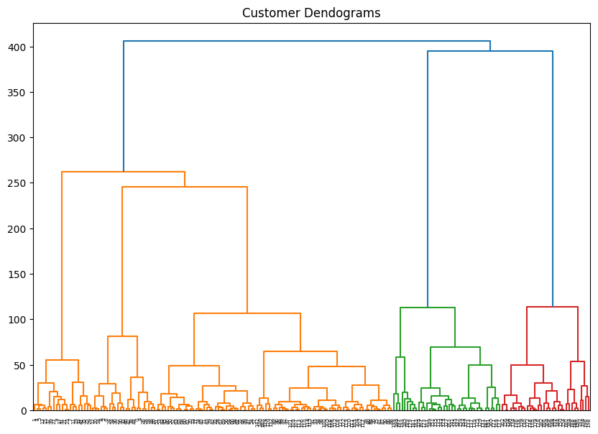

We get the number of clusters = 5 from the above dendogram, now apply AGNES to create 5 clusters.

from sklearn.cluster import AgglomerativeClustering  
  
cluster = AgglomerativeClustering(n_clusters=5, metric='euclidean', linkage='ward')  
labels_ = cluster.fit_predict(data)

labels_

array([4, 3, 4, 3, 4, 3, 4, 3, 4, 3, 4, 3, 4, 3, 4, 3, 4, 3, 4, 3, 4, 3,  
 4, 3, 4, 3, 4, 3, 4, 3, 4, 3, 4, 3, 4, 3, 4, 3, 4, 3, 4, 3, 4, 1,  
 4, 1, 1, 1, 1, 1, 1, 1, 1, 1, 1, 1, 1, 1, 1, 1, 1, 1, 1, 1, 1, 1,  
 1, 1, 1, 1, 1, 1, 1, 1, 1, 1, 1, 1, 1, 1, 1, 1, 1, 1, 1, 1, 1, 1,  
 1, 1, 1, 1, 1, 1, 1, 1, 1, 1, 1, 1, 1, 1, 1, 1, 1, 1, 1, 1, 1, 1,  
 1, 1, 1, 1, 1, 1, 1, 1, 1, 1, 1, 1, 1, 2, 1, 2, 1, 2, 0, 2, 0, 2,  
 1, 2, 0, 2, 0, 2, 0, 2, 0, 2, 1, 2, 0, 2, 1, 2, 0, 2, 0, 2, 0, 2,  
 0, 2, 0, 2, 0, 2, 1, 2, 0, 2, 0, 2, 0, 2, 0, 2, 0, 2, 0, 2, 0, 2,  
 0, 2, 0, 2, 0, 2, 0, 2, 0, 2, 0, 2, 0, 2, 0, 2, 0, 2, 0, 2, 0, 2,  
 0, 2], dtype=int64)

Plotting the Data

plt.figure(figsize=(10, 7))  
plt.scatter(data[:,0], data[:,1], c=cluster.labels_, cmap='rainbow')

<matplotlib.collections.PathCollection at 0x1b636125290>

